**SENDGRID INTEGRATION WITH PYTHON**

|  |  |
| --- | --- |
| Date | 13 NOV 2022 |
| Team ID | PNT2022TMID36392 |
| Project Name | NUTRITION ASSISTANT  APPLICATION |

**STEP 1:**

REQUIREMENTS:

Python 2.6, 2.7, 3.4 or 3.5.

**STEP 2:**

Create an API key

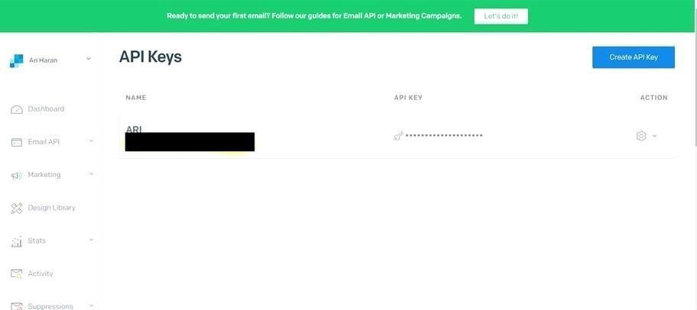

**STEP 3:**

INSTALL

PAKAGE: > pip installsendgrid

**SETP 4:**

SEND EMAIL

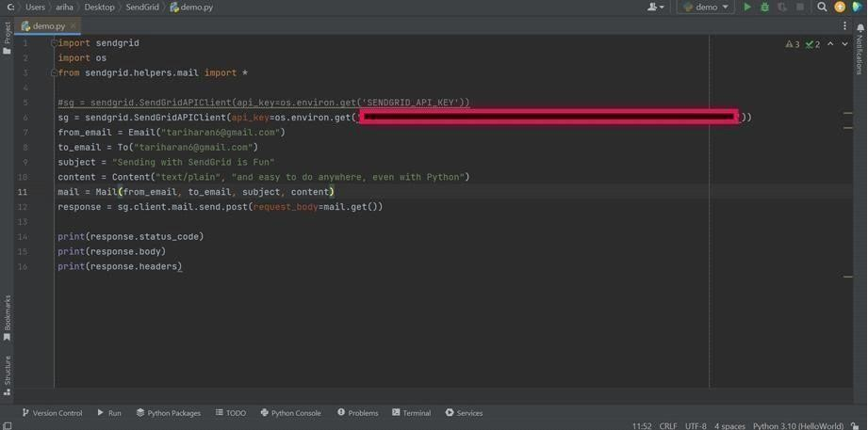

**SENDGRID PYTHON CODE :**

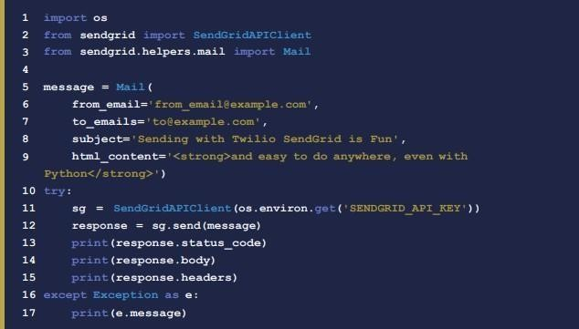

**HTTP CLIENT PROGRAM**



